 | Cumulative risk assessment of pesticide residues  Brussels, 11-07-13.  Contact : Hans Muilerman, hans@pan-europe.info, tel. 0031655807255

To: Mr. Tonio Borg
European Commissioner for Health and Consumer Policy
European Commission
B-1049 Brussels.

Concerning : Cumulative risk assessment of pesticide residues.

Dear Commissioner Borg,

In 2005 we celebrated the new Residue Directive 396/2005 and one of the great new elements in this directive was the provision to take cumulative effects of pesticide residues into account from that moment on. Or, at least, as soon as Food Authority EFSA published the methods to do so.

Now, we are already 8 years later and while the average citizen in Europe is consuming dozens of different pesticide residues every day, there is no cumulative assessment done. Therefore people in Europe are still not protected against the potential harmful effects of mixtures of pesticides. PAN Europe believes this is a shame and urges the Commission to work on this unacceptable situation.

While methods were already available in 2005 and even long before that time such as the Relative Potency Approach in the USA, EFSA hesitated and lost their time on all kinds of opinions on assessment groups. We know that the majority of EFSA PPR panel members considers cumulative effects hardly a serious topic and this could very well be the reason for the lack of progress we've seen throughout all these years. We do not understand how this lack of progress was allowed and why it took until 2012 when EFSA management finally withdrew the mandate of the PPR-panel.

We would like to know what DG SANCO’s position was during this massive delay. Can you please inform us on your initiatives to speed up the work of EFSA?

In the meantime other questionable elements are added to EFSA’s cumulative operation which -again- might throw 'sand' in the machine of cumulative assessment. In particular, we noticed the work of the research programme ACROPOLIS (FP7) -managed by fruit & vegetable trade organisation Freshfell- that seems to play a determining role in the cumulative assessment of EFSA. This research program aims to promote 'probabilistic' tools in cumulative risk assessment. And when commercial organisations promote a tool, you can be reasonably sure that their main mission is not to protect the health of citizens but their own commercial interest, this is their job. And indeed, taking a closer look at this 'probabilistic tool', it is clear that the objective of this tool is to allow a certain part of the population to be harmed.

This 'probabilistic approach' would also mean a paradigm change in the pesticide residue policy field. Until now –in the EU as well as in the work of the WHO- a deterministic approach is followed (see discussion paper of WHO attached: "such a change of policy would mean a fundamental change for CCPR"). We cannot understand that this potential paradigm change is developed in research programs, managed by food traders and that it might be subsequently introduced as a new policy.

We think it is DG SANCO's job to develop and propose tools and its duty to involve the Parliament and the pubic in discussions on big policy changes. And certainly not allow tools to be introduced and developed by commercial forces, supported by industry consultants. The Residue Directive is clear, stating that "any harmful effect" needs to be prevented and a high level of protection ensured and the probabilistic tool is simply not in agreement with it.

We urge you not to accept the probabilistic tool and force EFSA to start a deterministic cumulative assessment of all residues now. For some categories cumulative effects can be calculated; for the majority of the cases scientific information on potential cumulative effects is lacking. We therefore propose to add an extra safety factor of 10 in all cases on top of the methods developed by EFSA to account for unknown cumulative effects

We hope for your reaction,
Sincerely yours,
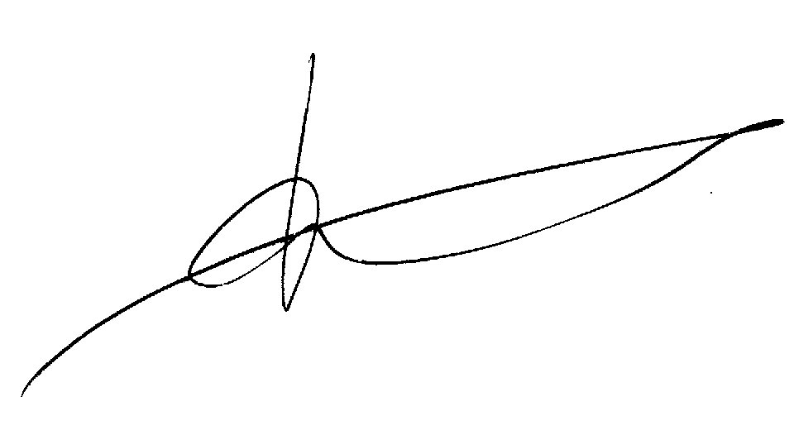

Hans Muilerman.
PAN Europe.

